

Willetton Senior High School

Year 11 AEECO 2020

Assessment 2

Name:

Teacher: ANSWERS Your Mark: _________/40

TYPE: Short Answer
OUTCOMES: Outcome 1: Economic inquiry; Outcome 2: The operation of the economy

WEIGHTING: 7.5%

CONTENT: Elasticity

Section 1: Multiple Choice (10 marks)

Section 2: Short Answer (30 marks)

Time allowed: 50 minutes

Conditions:

This assessment is to be written in class without notes.

SECTION 1: MULTIPLE CHOICE (10 marks)

- Which of the following statements is correct?
The demand for Nike shoes is more elastic than the demand for shoes in general.
(b) The demand for luxuries is less elastic than the demand for necessities.
(c) The demand for a narrowly defined good is less elastic than the demand for a more broadly defined good.
(d) The larger the proportion of income spent on a good, the smaller the elasticity
of demand.

- Suppose the price of a ticket to a Taylor Swift concert is $160 and at that price, the quantity of tickets demanded is 17,000. Using the midpoint method, if Taylor raises the price to $200 and the quantity demanded decreases to 16,000, the price elasticity of demand for her concert tickets is
(a) 3.67
(b) 0.72
(c) 0.67
(d) 0.27

- If a small percentage increase in the price of chocolate causes a larger percentage increase in the quantity supplied, the
(a) supply of chocolate is inelastic.
(b) demand for chocolate is elastic.
(c) supply of chocolate is elastic.
(d) demand for chocolate is inelastic.

- If the supply for wheat is inelastic, shifts in the demand curve will lead to

(a) large changes in quantity traded, but only small changes in price.
(b) large changes in price, but only small changes in quantity traded.
(c) large changes in both price and quantity traded.
(d) small changes in both price and quantity traded.

- Suppose that the income elasticity of demand for fresh fruit is greater than 1.0. This means that

(a) fresh fruit is an economic necessity.
(b) a smaller portion of buyers' incomes will be spent on fresh fruit as incomes rise.
(c) a greater portion of buyers' incomes will be spent on fresh fruit as incomes rise.
(d) a given percentage increase in income will generate a smaller percentage increase in the quantity demanded of fresh fruit.

- The demand curve in the figure above illustrates a product whose price elasticity of demand is equal to

  - infinity.
  - zero at all prices.
  - a different amount at different prices.
  - one at all prices.

- Producers’ total revenue will increase if

    - income falls and the good is a normal good.
    - the price rises and demand is inelastic.
    - the price rises and demand is elastic.
    - income increases and the good is an inferior good.

- If goods are complements, their

  - Income elasticities are negative.
  - income elasticities are positive.
  - cross elasticities are positive.
  - cross elasticities are negative.

- Of the following, which one is most likely to have a negative income elasticity of demand?

  - Shoes.
  - Tennis ball.
  - CBD bus travel.
  - Frozen yoghurt.

- Demand is perfectly inelastic when

(a) the good in question has perfect substitutes.
  - shifts in the supply curve results in no change in price.
  - shifts in the supply curve results in no change in quantity demanded.
(d) shifts in the supply curve results in no change in the total revenue from sales.

SECTION 2: SHORT ANSWER (30 marks)

Question 1: Price Elasticity of Demand and Total Revenue (10 marks)

The following table shows the demand for chocolate at various prices.

Price ($) | Demand | Total Revenue  $
1 | 4,000 | 4,000
2 | 3,600 | 7,200
3 | 3,240 | 9,720
4 | 3,000 | 12,000

- Fill in the Total Revenue column at each price in the above table. (2 marks)
½ mark for each correct answer

- Based on the changes in total revenue, state and explain briefly why is demand for chocolate elastic or inelastic between $3 and $4. (1 mark)

Demand for chocolates is inelastic (1/2)
When price increases, TR also increases (1/2)

- Calculate the price elasticity of demand coefficient when price changes from $2 to $3 using the midpoint method. Show all your calculations. State the midpoint formula and whether chocolate is elastic or inelastic in this range. (3 marks)
Midpoint Formula
Ed= △Q/Qave x Pave/△P (1)
= 360/3,420 x 2.5/1 = 0.26 (1)
Chocolate is inelastic (1)

- Describe the relationship between total revenue and price elasticity of demand. (4 marks)

Define Total Revenue/ Price Elasticity of demand (1)
When Price increases and TR increases, demand is inelastic (1)
When Price increases TR decreases, demand is elastic (1)
When Prices changes and TR remains the same, demand is unitary elastic (1)

Question 2: Price Elasticity of Demand and Tax (10 marks)

This question refers to the graph below showing the hypothetical market for recently released DVD movies sold at a large retail store.

Market for DVDs

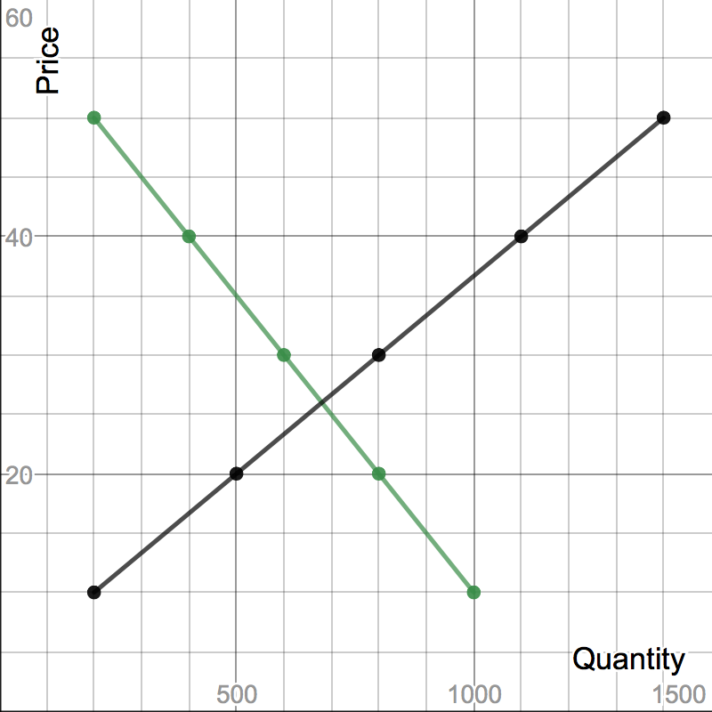
S+T

- What is the equilibrium price and quantity for DVDs? (1 mark)

Equilibrium price: $26 (1/2)
Equilibrium quantity: 690 (1/2)

- On the graph above draw a curve showing the imposition of a $10 tax on all DVDs. (1 mark)

- Explain the impact of the tax on producers, consumers and the government. Refer to the graph in your answer. (4 marks)

Producers sell less (1) 560 rather than 690
Consumers pay more (1) $32 rather than $26
Government tax revenue (1) $5,600
Reference to graph(numbers, shading or letters) for each of the parts of the question (1)

- DVDs are unitary elastic in the price range of $10 to $50. What does this mean and therefore who bears the greater burden of the tax? (2 marks)

Unitary elastic means the percentage change in price is equal to the percentage change in quantity demanded (1)
Tax burden would be shared equally between producers and consumers (1)

- The government prefers taxing goods that are inelastic. Give two reasons why this would be the case? (2 marks)

Answers may include:
- Greater tax revenue
- Less market distortion
- Consumers bear a greater burden of the tax, thus having a little impact on production
- Generally necessities, so burden falls across all members of society
Answers must be fully explained for full marks.

Question 3: Other Elasticities (10 marks)

- Define income elasticity of demand. Would the income elasticity of demand for smartphones be negative or positive? Provide a reason to explain your answer. (4 marks)

Income elasticity of demand refers to the responsiveness of demand to a change in consumer income (1)
Positive YED for smartphones (1)
Smartphone is a normal good (1/2) and relatively income elastic good (1/2)
As consumer income rises, demand for normal goods also rises (1)

- What does it mean when two goods have a positive cross elasticity coefficient? Give an example of two goods that may have a positive cross elasticity coefficient. (3 marks)

When two goods have a positive cross elasticity coefficient, they are substitutes (1)
Example- Coke and Pepsi, tea and coffee, butter and margarine etc (1)
Explanation- if the price of good A increases then the demand for good B decreases (an inverse relationship) (1)

- Using an example, explain the relationship between goods whereby the income elasticity of demand coefficient is equal to zero. (3 marks)

If the income elasticity of demand coefficient is zero, the quantity demanded remains the same even if income changes (1)
Example- necessity goods such as salt, haircut, water, electricity etc (1)
Explanation- any change in income will not affect the demand for these goods (1)

